Problem Statement

This project will be about how to do deploy code to dev/stage/prod etc, just on a click of button.

Link for the sample PHP application: <https://github.com/edureka-devops/projCert.git>

Business challenge/requirement

As soon as the developer pushes the updated code on the GIT master branch, a new test server should be provisioned with all the required software. Post this, the code should be containerized and deployed on the test server.

The deployment should then be built and pushed to the prod server.

All this should happen automatically and should be triggered from a push to the GitHub master branch.

Steps for executing the solution:

•Use the Master VM for Jenkins, Ansible, GIT etc.

•Use the fresh instance for Jenkins Slave Node (Test Server)

•Change the IP address of the VMs accordingly

•Add Build Pipeline Plugin and Post-build task plugin to Jenkins on the master VM

•Install python, openssh-server and git on the slave node manually

•Use the image devopsedu/webapp and add your PHP website to it using a Dockerfile

•Push the PHP website, and the Dockerfile to a git repository

Below tasks should be automated through Jenkins by creating a pipeline:

1.Install and configure puppet agent on the slave node (Job 1)

2.Push an Ansible configuration on test server to install docker (Job 2)

3.Pull the PHP website, and the Dockerfile from the git repo and build and deploy your PHP

docker container. After. (Job 3)

4.If Job 3 fails, delete the running container on Test Server.

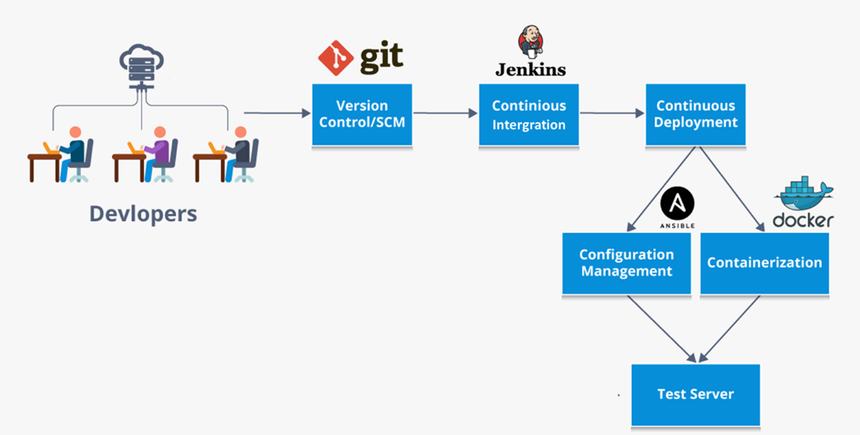

Solution:

* Use the Master VM for Jenkins, Ansible, GIT etc.

1. Create a centos server and install Jenkins.

sudo yum install epel-release java-11-openjdk-devel

sudo yum -y install wget

sudo wget -O /etc/yum.repos.d/jenkins.repo \

<https://pkg.jenkins.io/redhat-stable/jenkins.repo> --no-check-certificate

sudo rpm --import https://pkg.jenkins.io/redhat-stable/jenkins.io.key

sudo yum upgrade

sudo yum install jenkins

sudo systemctl start jenkins

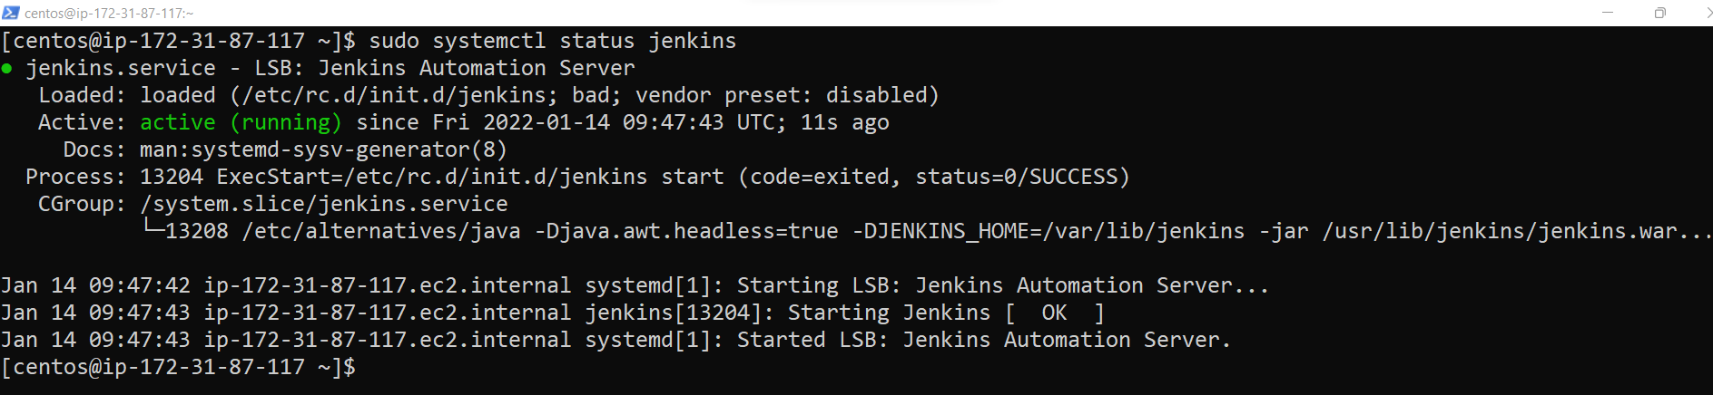

1. Install Git:

sudo yum -y install git



1. Install Ansible:

Sudo yum install -y ansible

|  |
| --- |
| # download and install |
|  |
|  | antversion=1.10.3 |
|  | wget http://archive.apache.org/dist/ant/binaries/apache-ant-${antversion}-bin.tar.gz |
|  | sudo tar xvfvz apache-ant-${antversion}-bin.tar.gz -C /opt |
|  | sudo ln -sfn /opt/apache-ant-${antversion} /opt/ant |
|  | sudo sh -c 'echo ANT_HOME=/opt/ant >> /etc/environment' |
|  | sudo ln -sfn /opt/ant/bin/ant /usr/bin/ant |
|  |  |
|  | # check installation |
|  | ant -version |
|  |  |
|  | #cleanup |
|  | rm apache-ant-${antversion}-bin.tar.gz |

•Use the fresh instance for Jenkins Slave Node (Test Server)

Create a new centos virtual machine.

Install java -> sudo yum -y install java

From the master Jenkins go to

Jenkins-> Dashboard->Manage Jenkins -> New Node->

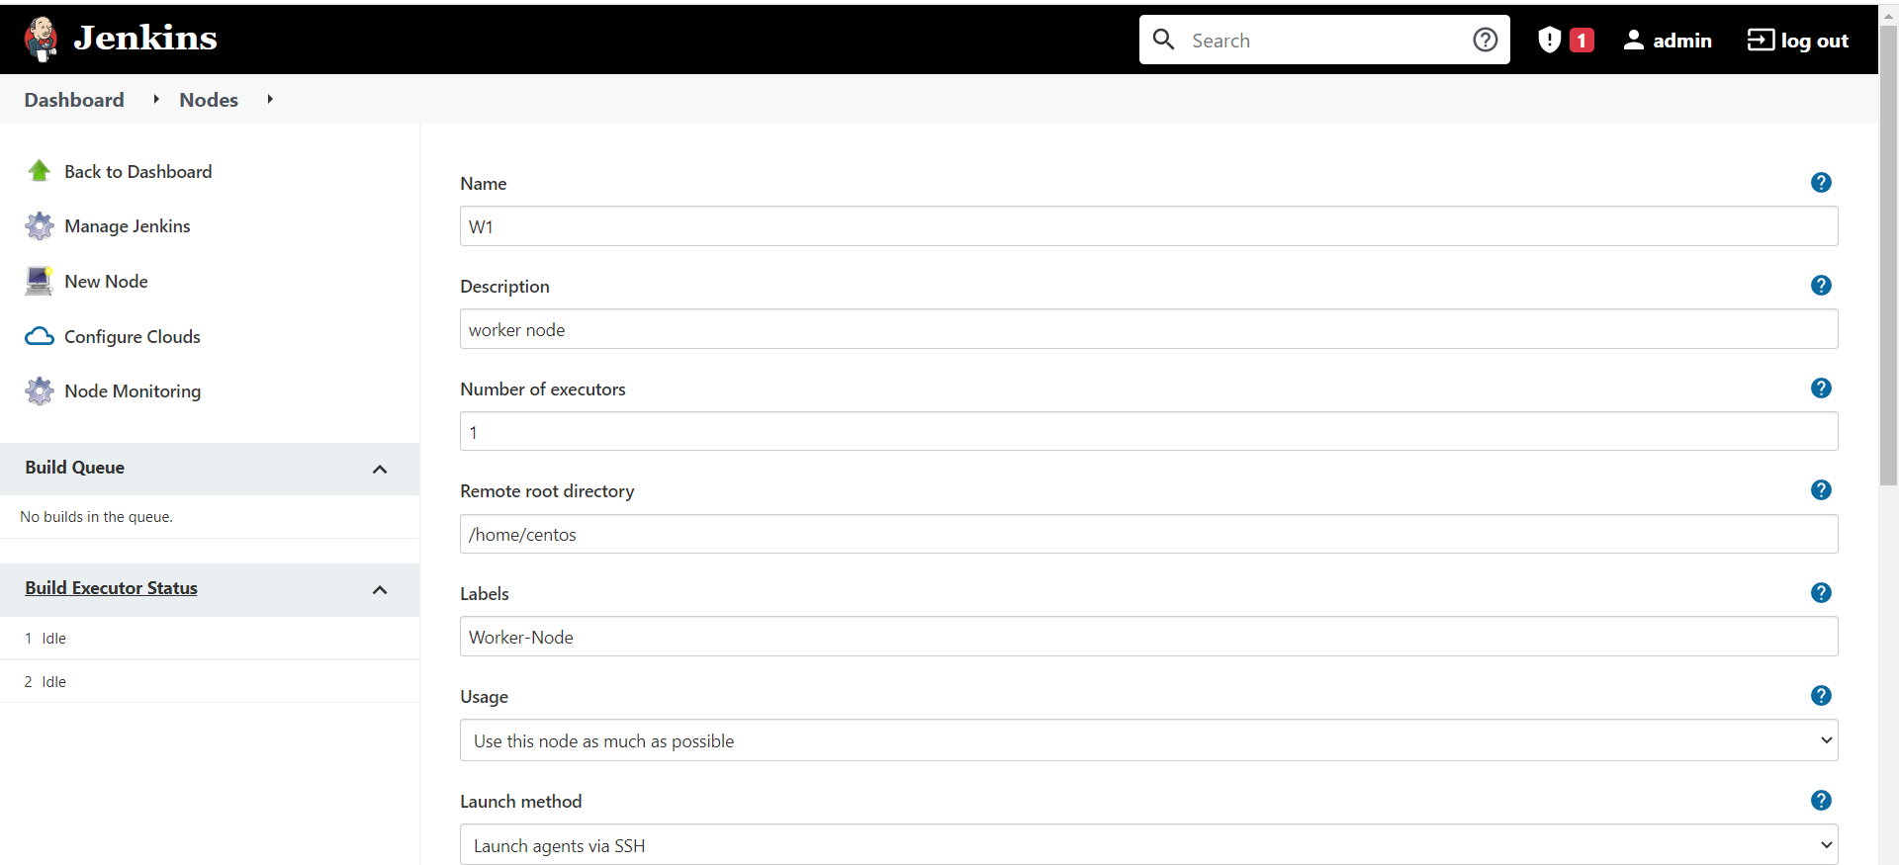

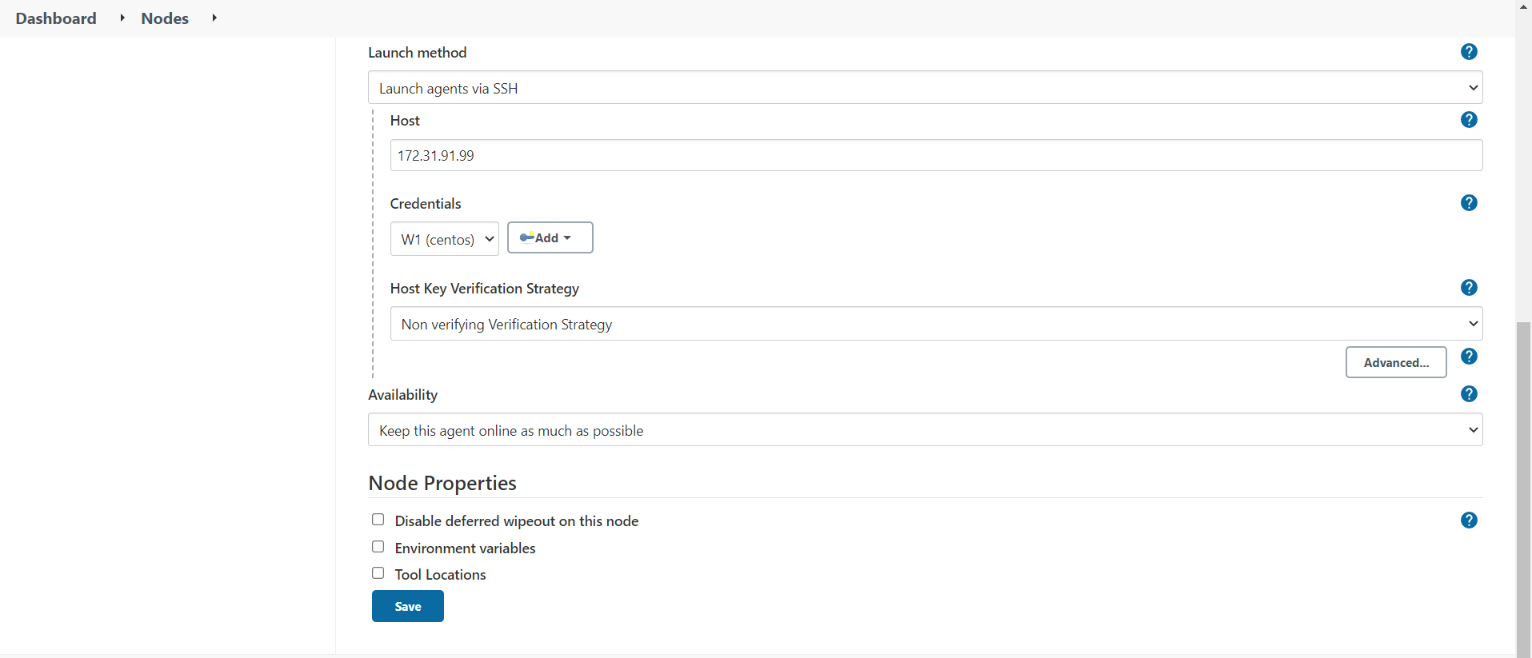

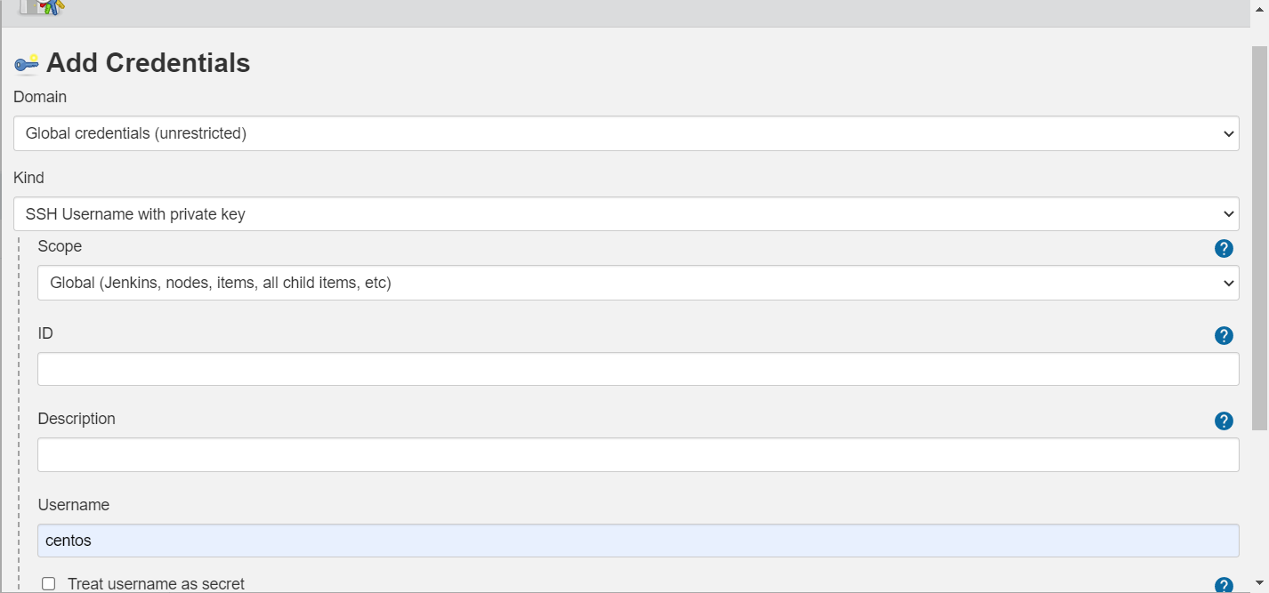

Once new node connected we can see the below screen from Jenkin:

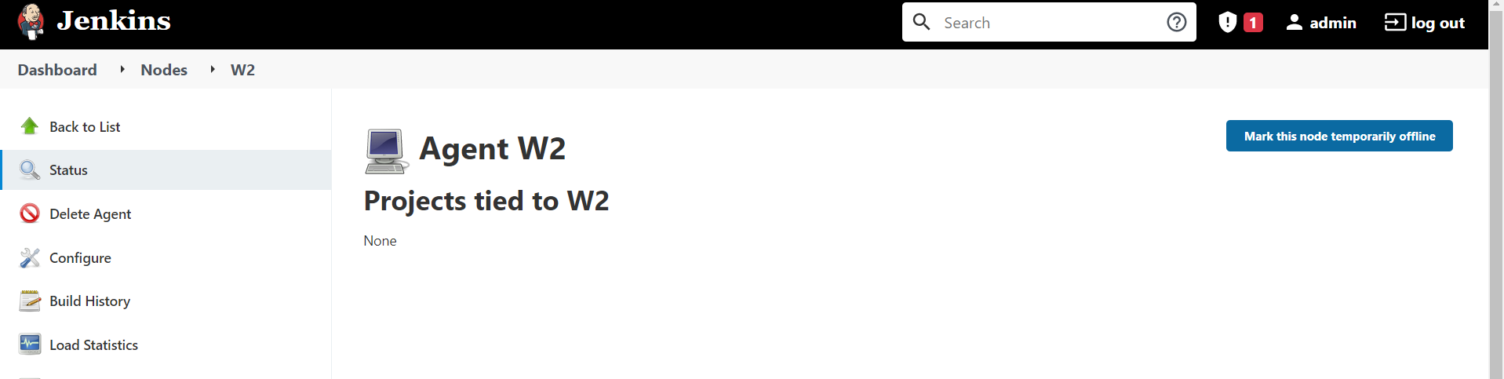

•Change the IP address of the VMs accordingly

•Add Build Pipeline Plugin and Post-build task plugin to Jenkins on the master VM

•Install python, openssh-server and git on the slave node manually

sudo yum install -y python3

sudo yum -y install git

sudo yum –y install openssh-server openssh-clients

sudo systemctl start sshd

sudo systemctl enable sshd

sudo systemctl status sshd

•Use the image devopsedu/webapp and add your PHP website to it using a Dockerfile

•Push the PHP website, and the Dockerfile to a git repository

docker container run -dt --name chiney1 -p 8080:80 -v /home/centos/projCert/:/app-data devopsedu/webapp

sudo apt-get install openjdk-11-jdk

java -version

ls .bashrc

nano .bashrc

$JAVA_HOME

echo $JAVA_HOME

export JAVA_HOME=/usr

export PATH=$JAVA_HOME/bin:$PATH

wget -q -O – <https://pkg.jenkins.io/debian-stable/jenkins.io.key> | sudo apt-key add –

sudo sh -c 'echo deb https://pkg.jenkins.io/debian-stable binary/ > /etc/apt/sources.list.d/jenkins.list'

sudo apt-get update

sudo apt-get install jenkins

2)

sudo apt-get update

sudo apt-get dist-upgrade

sudo apt-get install apache2

sudo apt-get update

sudo apt-get install -y software-properties-common

sudo add-apt-repository ppa:ondrej/php

**tep 2. Install php5.6 on ubuntu 16.04**

sudo apt-get update

sudo apt-get install -y php5.6

**Step 3. To know the version install**

php -v